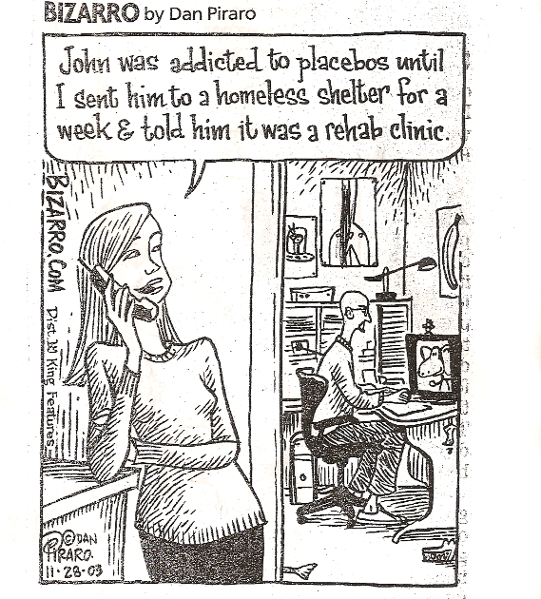

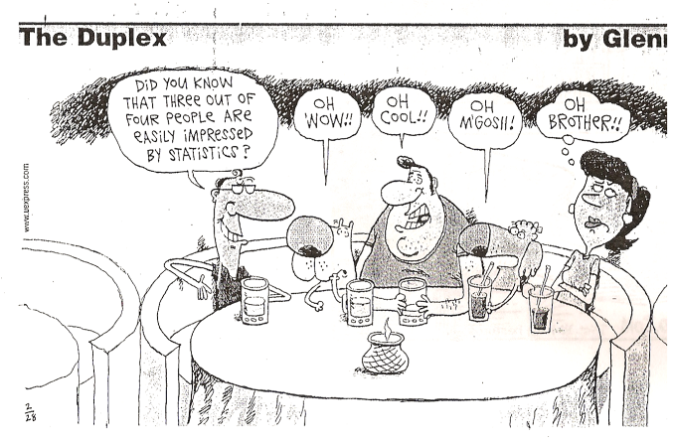


http://www.district196.org/evhs/People/baileyrcweb/


Randy Bailey -- EVHS Mathematics & Statistics
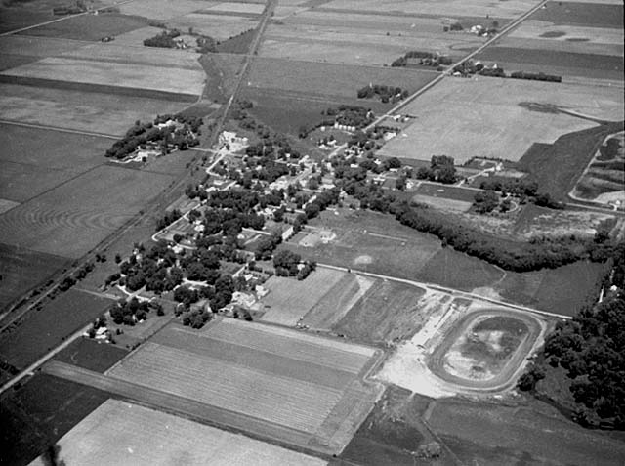

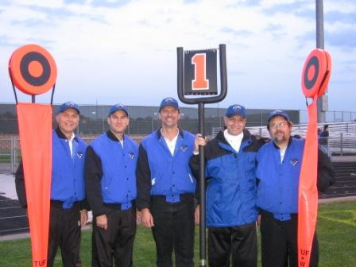
Hello, Scholars and Visitors! A bit o' miscellaneous trivia:
I'm from beautiful Lansing (the picture above shows the whole town!), near Austin, MN: Spamtown, USA. I hold BS and MEd degrees in mathematics education from the University of Minnesota, and spent '03-04 as the Visiting Master Teacher in math & statistics at St. Olaf College. I'm a private pilot; haven't crashed yet! Interested in flying?. Some sweet Eastview things: Debate , NHS , Math Team , Mr. Haugh , our nationally ranked football chain gang! Two of the world's great shrines (and my favorite places!) are here and here.

NOTE: As of fall 2011, I will be on leave from EVHS & my school email may not work. Try the phone book, or my home email: randy dot bailey at frontiernet dot net
2010 AP Stats Exam results are back!
Letter to incoming Fall 2011 AP Statistics Scholars!
***AP Stats Course & Registration Info 2011-12*** (further info via AP Stats course link below)
A dose of academic reality?
Cookie recipes from my lovely bride!
Carleton 2010: Top Two Tips for new (and other) AP Stats Teachers pdf
"Welcome Wagon" document for new (and other) AP Stats Teachers
Hour(s) | Class / Link | Location of Learning
1st, 2nd, 4th, 5th | AP Statistics | A104: the "Dark Crucible of Knowledge"

sweet-n-tasty email: randy.bailey@district196.org or randy.bailey@frontiernet.net
EVHS Math/Stats office: 952-431-8962; voicebox: 651-683-6969; #94403

Bailey’s Top Two Tips for beginning (and other) APStat teachers

This document, and all others referenced herein, are available electronically at my website http://www.district196.org/evhs/People/baileyrcweb/ ….or just google “Bailey EVHS”

1)*** Join, monitor, and submit to the APStat “electronic discussion group” ***
http://apcentral.collegeboard.com/apc/public/homepage/7173.html

2a) Check the APS FAQ list (especially the “General Info for New Teachers”!)
http://www.mrderksen.com/faq.htm

2b) Stuck? Check the APStat Discussion Group Archives
(common questions – and expert answers from ACTUAL GURUS -- are here)
http://mathforum.org/kb/forum.jspa?forumID=67

2c) Use the APStat resources at AP Central:
http://apcentral.collegeboard.com/stats

2d) Stuck on how to teach/understand ______________________ ?
Check the archives. Check FAQ. Use an activity or lab.

2e) Open a professional account at AP Central and get rolling on your audit.
http://apcentral.collegeboard.com/apc/public/courses/teachers_corner/46361.html
LOADS of audit resources, including sample audits for all major books: http://web.mac.com/statsmonkey/APStats_at_LSHS/AP_Audit.html

2e) Use the variety of resources available!
Online resources your book provides, esp. quizzes & applets, applets, applets.
Newspapers/magazines have examples every day that you can use.
Teachers’ websites: Jason’s Statsmonkey, etc. Great list of these is available at FAQ!!

2f) Make (i.e., copy / heist / steal) a schedule -- and stick to it.
Schedules available with your book’s resources, on FAQ, Statsmonkey, etc.
The kids WILL seem to “need just one more day….” for most every topic!
Trust that many stat ideas WILL ‘come together’ later in the course.

2g) Success on the AP Exam is our shared goal – from Day 1.
Hand out the APS formulas & tables on day 1. Open use on ALL tests, HW, etc.
Use old FRQ’s for homework, on exams, for test prep, everywhere, from Day 1.
ALL old FRQ’s are available from AP Central, and an index of year/question vs.
topic is available at sites below! This is pure sweetness!
http://apcentral.collegeboard.com/apc/members/courses/teachers_corner/47425.html
http://web.mac.com/mrmathman/MrMathMan/Downloads_files/FR%20correlation.doc
Let kids ‘grade’ their own FRQ’s via associated Scoring Guide. Mmmm good!

2h) Keep taking workshops. Keep taking workshops. Keep taking workshops.

2i) it WILL be better in year (X+1) than it was in year X. (by mathematical induction)

AP Statistics IS much harder to teach well than any m _ _ h course.
…AND IT IS MUCH MORE REWARDING.

Send me a note – any time, any reason – at randy.bailey@frontiernet.net
http://www.district196.org/evhs/People/baileyrcweb/

From Derksen’s APStats FAQ @ http://www.mrderksen.com/faq.htm Mmm Sweetness.

General Information for New Teachers
1. Why divide by n-1 in the standard deviation formula?
2. How do I explain R-squared?
3. Do I have to teach log and power re-expressions?
4. What's the difference between confounding and lurking variables?
5. What's the difference between independence and mutually exclusive?
6. How much probability do I need to teach?
7. What's the deal with adding variances? Var(2X) =?? Var(X) + Var(X)
8. I'm running out time and what can I do (especially with inference for slope)?
9. How much work do students need to show on the exam?
10. Which textbook should I pick?
11. What's a good review book?
12. Why do I use the pooled-p for a 2-proportion z-test?
13. How do you solve Sally and Betty? 2002 #39 MC?
14. How do I promote my class?

Resources

** Where can I find good Internet applets?
** Where can I find quality activities for my class?
What journals and publications make for valuable reading?
What books and texts will I find valuable as a resource to keep handy on my bookshelf?
** Where can I find loaded dice?
Where can I find web sites about AP Statistics?
Which video series would be valuable for AP Statistics?
** Where can I get information about AP Statistics workshops?

The Exam

** What content are students responsible for on the exam?
What tables and formulas are provided for student use during the exam?
How do other teachers review for the exam?
Are there any good review books available?
What do experienced teachers recommend to do AFTER the exam?
Where can I obtain copies of previous exams and rubrics?
When will ETS release more multiple-choice questions?
Can I get information from the faculty consultants about their past Reading experiences (so I can better prepare my students for next year's exam)?
What is the College Board policy on calculator use during the exam?
What can I tell my students to help them prepare for answering free response questions that require the use of a calculator?

Google “Bailey EVHS” or go directly to http://www.district196.org/evhs/People/baileyrcweb/ and then click “AP Statistics”…..
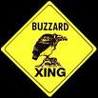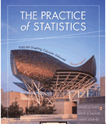
"I keep saying that the sexy job in the next 10 years will be statisticians. And I'm not kidding." -- Hal Varian, Chief Economist at Google
AP Stats Course/Registration Info
Welcome letter for new 2011-2012 AP Statisticians!
Bailey's Top Two Tips for New (and other) APStats teachers and in pdf
Why Take AP Stats? Read this sweet informational brochure.....
Why should anybody ever take ANY stats? This 2 minute video will tell you.
Our AP Stats MOODLE site!
AP Stats Exam SCORING SIMULATOR!
Countdown to the AP Stats Exam: High Noon on May 16th, 2012:
334 days 19 hours 25 minutes 21 seconds

AP Stat INFO: | Syllabus! | Book & Online Quizzes | Schedule/ Assignments! | Bailey's Secrets to Stat Success | College Board audits EV Stats! | CB's APStat site
LABS: | M&M data transformation Lab:  Random Variables(MS Word)  Random Variables (html) | Oreo Lab  2-sample t test | M&M  z-int/z-test for a proportion | M&M / Skittles  z-test/z-int for a mean (easily adapt to t-procedures) | M&M Chi-Square  Goodness-of-Fit | Titanic ChiSq:  Word  Html
FUN: | turn up your sound and take a nice Study Break? | Our Manatee Page! | Ann's Cookie Recipes! | Zombie Preparedness Initiative | Book Checkout | Extra Motivation?
RESOURCES: | Coll. Credit Policy Project | Misc.Links & fun | APS review helper books | How Parents Can Help | Parent / Student Portal | Stat Careers: pwrpnt presentation
SWEET: | cool Stat talk! | Stats Rap Video! | Which Procedure When? | Exam FAQ | 2010 (& prior) AP Exam Results! | Psychic Mind Reader!
FUN and SWEET: | EV Honor Code! | Online Textbook Checkout ! | Two big tips for college success! | The Dead Grandma Problem | MCA Prep help!
MORE FUN: | Class Shirts 1 2 3 4 5 6 7 8 9 10 11 12 13 14  11F 11B | Shirt from Anna's pal! | What IS "Statistics", anyway? | a cool Stats lecture! | Wall Street Journal's Stats Blog | Is H.S. really Different than College???

Eastview High School Statistics Department
Randy Bailey: Office A110, phone 952-431-8962, Email randy.bailey@district196.org

ADVANCED PLACEMENT STATISTICS
“Statistical thinking will one day be as necessary for effective
citizenship as the ability to read and write.” H. G. Wells (1866-1946)

I. COURSE OBJECTIVES—what successes are we targeting?
a. demonstrated mastery of the AP Stats curriculum as determined by the College Board.
b. use the tools of statistics to develop good problem-solving, critical thinking, and citizenship skills.
c. prepare for further success in college–level mathematics
d. keep college major and subsequent career options open.
e. GET COLLEGE CREDIT FROM THE AP STATS EXAM: 12:00 noon TUESDAY, MAY 16th, 2012.

II. EXPECTATIONS—what qualities will it take to be successful?
a. your best effort and greatest responsibility. b. respect for all those in the room.
c. bring all proper and no improper materials to class. d. compliance with EVHS absence and tardy policies.
e. knowledge of, respect for, and compliance with the EVHS academic honesty and integrity policy.

III. SUPPLIES—what items do I need to be successful?
a. 3-ring binder, paper, pencil b. TI-83/84/+ graphing calculator and manual
c. awesome positive attitude d. book cover

IV. ASSIGNMENTS/HOMEWORK—what should I do to be successful?
a. Read each section before we cover it in class.
b. Have all work completed to the best of your ability before class begins.
c. Avoid late work. There is no guarantee of any credit. Don’t get, be, or stay behind.
d. Regular attendance is key to math success. There are two kinds of absences—those you don’t know are coming and those you do. If you miss class for an unforeseen reason (i.e. sickness) your responsibilities are 1) connect with classmate(s) and get copies of any notes, tutoring, etc.; 2) stop by and see me before school when you return to pick up materials and schedule any makeup; 3) complete all makeup within the “2-for-1” policy set by EVHS. If you do know about an upcoming absence (i.e. field trip, activity practice, vacation, etc.) then your responsibilities are 1) notify me well ahead of the absence; 2) pick up any needed materials as soon as they’re available; 3) arrange for classmate(s) to feed you copies of notes, handouts, tutor you, etc.; 4) possibly complete the work prior to missing class; 5) be caught up and in step with the class when you return. The “2-for-1” makeup rule does not apply to pre-planned absences. Every opportunity comes with a responsibility.
e. Don’t let outside commitments get in the way of classroom success.
f. Be responsible about homework without having it ‘checked’ daily. You’re in a college-equivalent AP class.

V. TESTS & QUIZZES—how will my success be measured and evaluated?
a. Tests will be announced. Quizzes may or may not be announced.
b. Time will usually be scheduled for review before chapter tests.
c. If you miss a test, quiz, or review day, you will generally make up the test/quiz the day you return. If you are gone, it is your responsibility to stop by before school the next day to make a plan.

VI. GRADES—how will my success be reported?
a. Our shared goal is DEMONSTRATED MASTERY OF THE MATERIAL on the way toward acing the AP exam. Percentage weights used for computerized grading during the quarter: 20% Assignments/Homework; 80% Tests, Quizzes, Projects; possible Cumulative Exam(s) covering the qtr./semester’s material. I also reserve the right to use my own non-computerized professional judgment of your mastery in assigning your transcript grade.
b. Approximate cutoffs: 93%+=A, 90%+=A-, 87%+=B+, 83%+=B, 80%+=B-, 77%+=C+,73%+=C, 70%+=C-, under 70% = my professional judgement.
c. Pass/No Credit Option: 70%+=Pass, <70%=No Credit. Confirm req’s w/Bailey before choosing this option.

VII. HELP !! —How can I increase my opportunity for success?
Options include study groups during study hall & outside school w/classmates, extra work before/after school, peer tutors, Homework Hotlines, and other math teachers. In AP Statistics, another great resource is the variety of online resources available. Our #1 shared goal is mastery of the course material on the way toward acing the AP exam, and I am willing to help out a responsible, hard-working student in most any way I can. If you have suggestions to improve the class, please see me! Be sure and communicate your needs and concerns.

The first part of my schedule:

Cls | Qtr | Day | Date | ch.sec | Things to help you learn: practice probs, resources, etc. | Done?
1 | 1 | T | 5-Sep | 1 | Play Greed game. READ xii-xvii & sec. 1.1 http://www.mrderksen.com/art8.htm http://www.math.yorku.ca/SCS/Gallery/
2 | 2 | W | 6-Sep | 1.1 | 6, 8, 9, 10, etc. http://babynamewizard.com/namevoyager/lnv0105.html http://www.math.yorku.ca/SCS/Gallery/milestone/sec5.html http://researchnews.osu.edu/archive/chainspix.htm
3 | 3 | Th | 7-Sep | 1.1 | (12), (13),(15), 16, 17 19, etc http://www.math.yorku.ca/SCS/Gallery/ http://www.stat.sc.edu/~west/javahtml/Histogram.html http://www.rossmanchance.com/applets/Histogram.html http://www-personal.umich.edu/~mejn/cartograms/
4 | 4 | F | 8-Sep | 1.1 | 20, 22, read 23-30. 29? READ 1.2 http://www.mrderksen.com/art3.htm http://www.mrderksen.com/art8.htm http://www.answers.com/topic/ogive http://www.pballew.net/arithm12.html#ogive
5 | 5 | M | 11-Sep | 1.2 | 31-34; read article: http://www.cancerguide.org/median_not_msg.html
6 | 6 | T | 12-Sep | 1.2 | 36, 38, 39, etc. http://abcnews.go.com/Technology/WhosCounting/story?id=2265555&page=1
7 | 7 | W | 13-Sep | 1.2 | 40,41,43, (check 48), etc.. Online Mult Choice!
8 | 8 | TH | 14-Sep | 1.2 | 45, 46... 50?, 51, 56, AP questions, Read Summary etc etc, Ch rev probs, Do as nec.
9 | 9 | F | 15-Sep | 1 | Ch 1 quizzalicious: in class AND take-along. Read 2.1
10 | 10 | M | 18-Sep | 2 | check quiz, more examples. READ 2.1.
11 | 11 | T | 19-Sep | 2.1 | 1, 2, 3, 4, 6, 7, 9, 11, 14, etc etc. READ 2.2.
12 | 12 | W | 20-Sep | 2.2 | 19-25, etc. http://www.kleinbottle.com/gauss.htm
13 | 13 | TH | 21-Sep | 2.2 | 26-29, etc etc from section 2.2 probs
14 | 14 | F | 22-Sep | 2.2 | 3 FRQ problems. Read 30-54, do as necessary for deep understanding AND mastery!
15 | 15 | M | 25-Sep | 2 all | Read 30-54, do as necessary, Online Practice MC
16 | 16 | T | 26-Sep | 2 | Ch. 1 & 2 Opportunity for Excellence. READ 3 intro & 3.1
17 | 17 | W | 27-Sep | 3.1 | check test. Reinforce scholarship habits. College Fair Day. 3 intro

And later in the year……
145 | 14 | TH | 27-Apr | TH | 26-Apr | 1-14 | Rev: Which Prcdr When? Sheet. Also MC fix/YMS Blue work day. FR's:
146 | 15 | F | 28-Apr | F | 27-Apr | 1-14 | Rev: Which Prcdr When?. MC Due, continue YMS Blue etc.
 |  | Sat | 22-Apr | Sat | 28-Apr | 1-14 | DRESS REHEARSAL. Brkfst @ 8, Exam @ 8:30
 |  | Sun | 23-Apr | Sun | 29-Apr | 1-14 | DRESS REHEARSAL. Brkfst @ 8, Exam @ 8:30
147 | 16 | M | 1-May | M | 30-Apr | 1-14 | Rev: All Things Linear
148 | 17 | T | 2-May | T | 1-May | 1-14 | Rev: All Things Random Variable
149 | 18 | W | 3-May | W | 2-May | F Lit | Rev: All Things Probability
150 | 19 | Th | 4-May | Th | 3-May | F Lit | Rev: Wild Card!
151 | 20 | F | 5-May | F | 4-May | 06 FR | Rev: Wild Card!
152 | 21 | M | 8-May | M | 7-May | 1-14 | Rev: Mnemonics: ShCtrSp, FrmDrStr, CnRndRep, PANIC, Phantoms. Tune up our calculators. Sleep the sleep of a well-prepared statistician.
153 | 22 | T | 9-May | T | 8-May | 1-14 | SHOWTIME! 12:00 NOON in MEDIA CENTER
154 | 23 | W | 10-May | W | 9-May | F Lit | AP Exam Debrief & discuss. Post-exam plans. Financial Lit Spreadsheet A vs. B
155 | 24 | TH | 11-May | TH | 10-May | F Lit | Financial Lit II: Otis' loans, pmts, debt. Wksht Probs, plus one of your own
156 | 25 | F | 12-May | F | 11-May | 06 FR | 48 Hr Wait period elapsed! GO OVER 2008 FRQ PROBS.

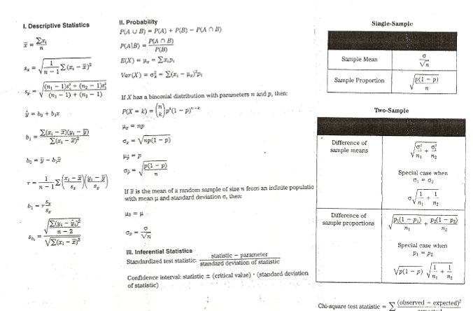
DAY ONE:

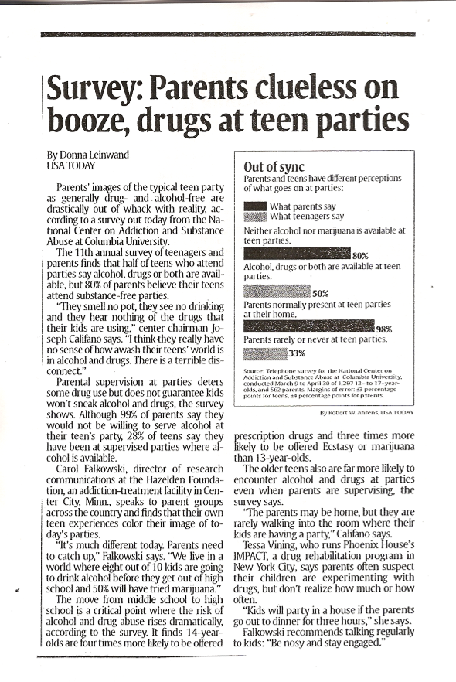

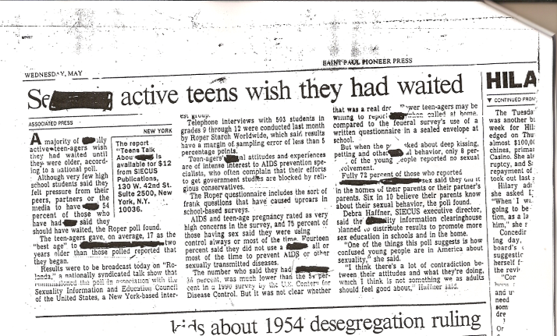

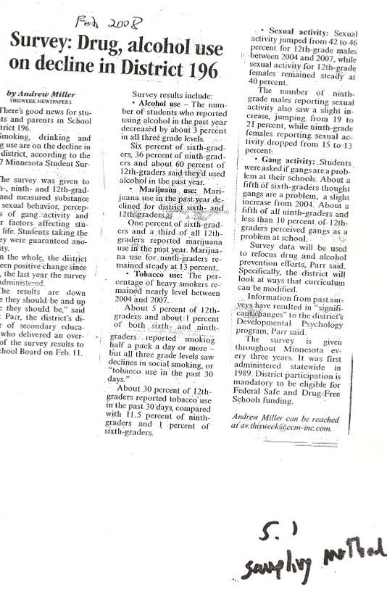

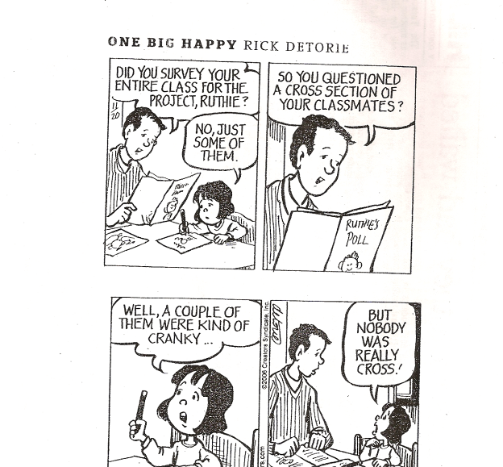

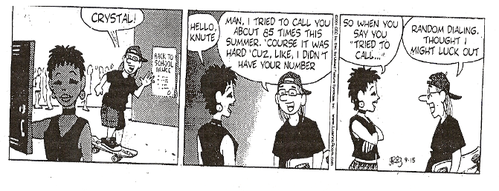
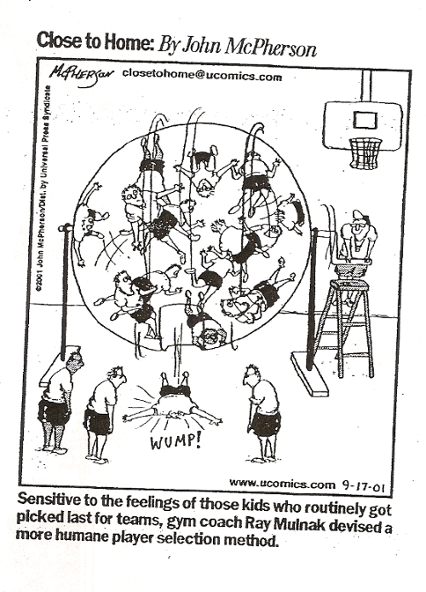

M&M / Skittles Candy Lab: z-interval for a mean & z-test of a mean
(easily adaptable to t-procedures)
Lab Sheet -- what I give the kids. it has a front & a back side.
Data Spreadsheet - to check answers etc.. Really neat if you can project it on board.
Template - an ALL-PURPOSE template for Confidence Intervals & Significance Tests!
Conclusions -- what their writeup might look like
Pictures of Scholars doing this lab: Picture1 Picture2 Picture3
Tips/hints for lab
-- on lab days, my kids are randomly assigned to a team. Every group of 4 seats has a name: Alpha, Bravo, Charlie, etc. Kids pick a slip of paper from a pile on the way in and go sit at the table with the name they picked. First thing: Tell everyone on your team your name. Second thing: say something nice about everyone on your team. OK, now start the lab!
-- have at least 2 (preferably 4) balances for the kids to weigh things.
-- remind them repeatedly that we have TWO DISTINCT tasks: 1) write a CI for the mean number of items in a bag and 2) do a sig test on the mfg's claimed mean net weight.
-- give each group paper plate(s), napkins, cups, etc.; see above pictures of kids doing lab (more pix avail if wanted)
-- remind them that for the weight test we care about NET weights (candy only!) not gross weights.
-- give each team 1 bag of MM, 1 bag of skittles. But if you want to cut things down (perfectly OK) , just do ONE candy.
--esp. for beginning statisticians: do ALL work on the Template sheet. Get used to a good format for writing CI's and Sig Tests.
-- put a copy of the data tally sheet on the overhead projector; have teams come up & fill in data as they get it.
-- If you've got Excel, load their numbers into the Data Spreadsheet in the appropriate places for a quick automatic check on their work. Even better if you can project this spreadsheet on the board for all the cherubs to see.
-- take pictures. Save for next year. Print a few & post in classroom. Use for recruiting next year.
-- I've got an MM PROPORTIONS lab that I'll be posting soon.
Please contact me with any other q's. -- randy.bailey@district196.org

APStat CandyLab 2011 x_________________________ Materials: 4 centigram balances; Per group: 47.9 g bag MMs, 61.5 g bag Skittles, plates, spoons, cups

Today’s tasks:
1) calculate confidence interval for the true (and unknown!) mean number of edible items in a sales unit.
2) test each manufacturer’s claimed mean net weight (μ) for its sales unit

Corporate policies:
-- all sampling of sales units must be of size n = ____.(# of groups)
-- each team will weigh & count 1 MM bag AND 1 Skittles bag, then contribute their data to the class.
-- even though you have data for BOTH candies, you only pick ONE candy to analyze: either MM or SK.
-- all confidence intervals must be listed at the 0.95 level.
-- all significance tests are done at the α = 0.05 level
-- the pop. std. deviation (σ) for NUMBER of items per bag is known to be 2. (thank you, Stats Fairy!)
-- the pop. std. deviation (σ) for WEIGHT is known to be = (1/30) μ. (thank you, Stats Fairy!)

Sample Data to be ORGANIZED & listed on reverse side. Do remaining work on CI/TS template sheet Reports must show all raw data, work, and methods clearly. Communicate your work and findings.
Reports must contain correctly calculated confidence intervals, with interpretation in context!
Reports must show a complete test of significance. Clear! Communicate! Concise! Context!!!!!!
Because sampled merchandise that is handled by serious researchers cannot be allowed to go back into stores for public sale, ALL sampled material must be destroyed at the conclusion of the study !!
Use the method of your choice for disposal.

x
Skittles | Weight
Skittles | Number
MM's | Weight
MM's | Number |  |  |  |  |  |  |  |  |  |  | `
 | Team | Alpha | Bravo | Charlie | Delta | Echo | Foxtrot | Golf | Hotel | India | Juliet | Kilo | Lima | x | σ | n

1st Period | M&M's |  | Skittles
 | # in bag | net wt (g) | # in bag | net wt (g)
Alpha | 55 | 48.24 | 61 | 64.81
Bravo | 57 | 49.6 | 55 | 58.8
Charlie | 53 | 46.88 | 61 | 65.6
Delta | 55 | 48.5 | 56 | 62.81
Echo | 54 | 47.49 | 57 | 61.36
Foxtrot | 54.5 | 48.41 | 62 | 66.05
Golf | 53 | 46.99 | 59 | 62.97
Hotel | 54 | 47.92 | 58 | 61.77
India | 55 | 48.99 | 60 | 63.87
xbar | 54.50 | 48.11 | 58.78 | 63.12
n | 9 | 9 | 9 | 9
σ | 2 | 1.60 | 2 | 2.05
95% m.o.e. | 1.31 |  | 1.31
95% CI:_+-_ | 54.5 +- 1.31 grams |  | 58.78 +- 1.31 grams
95% CI:( _,_) | ( 53.19 , 55.81 ) grams |  | ( 57.47 , 60.08 ) grams
 | Ho: μ = | 47.9 | Ho: μ = | 61.5
 | z = | 0.40 | z = | 2.36
 | p-value = | 0.689 | p-value = | 0.018
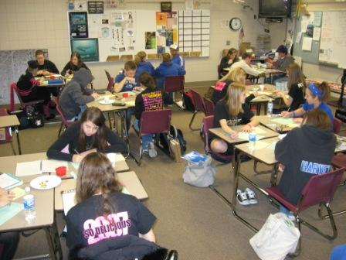
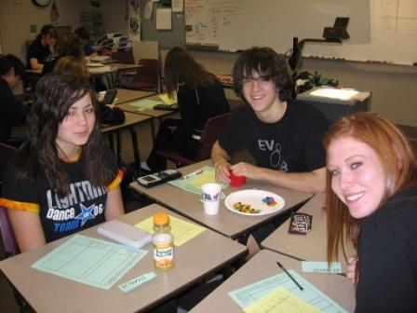

From a 2010 course evaluation:

“I did the homework and everything, but what really tied things together for me was the labs we did. Those are the days I learned the most about statistics”

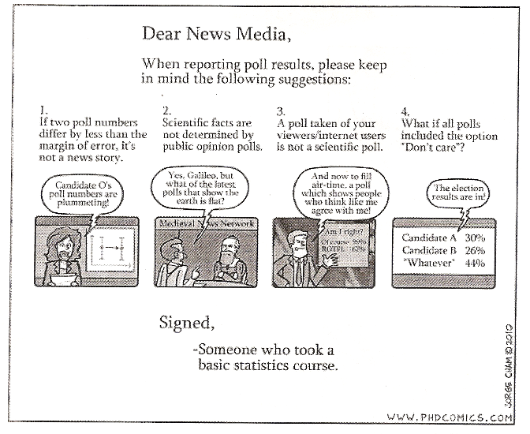


AP Statistics CAPSTONE RESEARCH
& Practical Final Exam:
BE A STATISTICIAN!

Executive Summary:
1) Identify & refine a researchable question or testable hypothesis with measurable variables
2) Design a proper experiment or observational study to generate appropriate data
3) Carry out your experiment or study
4) Do a full and proper analysis of resulting data in order to answer your question/hypothesis.
5) Choose & execute a proper method of presenting 1) through 4) to your peers….AND the Executives in Upper Management.

The emphasis is on the application of proper study design and data analysis techniques, not so much on gathering a huge data set and reaching an authoritative conclusion – but that’s nice, too!

OK, further details:
1) Identify & refine a researchable question or testable hypothesis with measurable variables
-- your question should be…worthwhile! interesting! valuable! do-able!
--
2) Design a proper experiment or observational study to gather appropriate data
-- surveys and/or use of existing data are VERY discouraged. YOU generate ORIGINAL data.
-- if you can’t get the data to analyze, a great idea…isn’t!
-- if your research involves people, be prepared for attendant ‘issues’!
-- if you do ANYTHING to or with human subjects, it must be approved by Upper Management.
3) Carry out your experiment or study
-- do you have the time? the equipment? the resources? the funding? the subjects?
-- Take PICTURES! Document your work!!
--
4) Do a full and proper analysis of resulting data in order to answer your question/hypothesis.
-- PANIC? PHANTOMS? Graphs! Charts!
-- conclusion(s)? items/ideas for further research that were suggested by your results?
--
5) Choose & execute a proper method of presenting 1) through 4) to the Executives in Upper Management.
-- consider how you might communicate the results…to expert and/or lay audiences.
-- powerpoint, PICTURES, video, skit, poster, booklet, packet, report, video, movie, slideshow, overheads, handouts, ___________________?, ____________________________?
Timeline:
May___: Intro to Capstone project. Take a look at some previous Capstones. Generate research question.
May ___: Completed form describing the research question, hypotheses, design, & data analysis plan. Refine ALL.
May ___: Refined/final description of research question, experiment/study design, and data analysis plan
May ___: Gather data. Raw data from your experiment/study should be IN.
May ___: All data should be IN and you’re doing analysis; starting to plan/generate yourpresentation.
May ___: Random assigment to a presentation slot on the calendar. (Then you can trade if you want!)
May ___ - ____: Presentations to the Class and Executive(s) in Upper Management. Balloting/grading.

Pr | # | Likely Day | Topic | Researchers
1 | 1 | T 3/29 | Rotten Apples: Air vs. 7Up | Shega Chodek
1 | 2 | T 3/29 | Answer Pattern: does it affect performance? | Race
1 | 3 | T/W ? | Froot Loops: Name Brand vs Generic | C Nels V Nels Sagstuen2 Bauer
1 | 4 | W 3/30 ? | Starburst Sensory Extravaganza X42 | LPetrsn Gebert EPedrsn Williams
1 | 5 | W 3/30 ? | Corner Pocket! Billiard Study | Kalafut deGuzman Olson2
1 | 6 | W 3/30 ? | Rainy Days Get Me Down: Weather vs Mood | Halvorsen Koch
1 | 7 | W 3/30 ? | Turn Turn Turn: Who follows the Law? | Reishus Larsen2
1 | 8 | W | Advertising Proyecto de la sweetnesse | Russell
1 | 9 | W/Th ? | Drain Brain: Reactions vs. Sleep | LVanKemp OVanKemp DawnFE
1 | 10 | Th 3/31 ? | O Say Can You Stand? Pledge Participation | Dorsch Edwinson Houser
1 | 11 |  | Breaking Silence: Sociability and Gender | Simbana Carpenter
1 | 12 |  | Marshmallow Abuse: burn baby burn! | McDermott
Pr | # | Likely Day | Topic | Researchers
2 | 1 | T 3/29 | Caribou Cage Match: Drink type vs. Gender | Welter Szempruch
2 | 2 | T 3/29 | Lemonade Stand: Ageism in a cup! | Hayden Woelfel1
2 | 3 | T 3/29 | Bad Breath: Lung Capacity vs.Gender | Dahlke Harvey
2 | 4 | T 3/29 | Slacker City: Gender Wars! | Folkerts Benner
2 | 5 | W 3/30 ? | Hang up & Drive! Cell Phones in Car | Wadsworth Galau
2 | 6 | W 3/30 ? | "Transmit" your love: Teachers vs. Students | Pellicci Lucke Spelbink Zhao
2 | 7 | W 3/30 ? | Re-Learning Relay Really Rocks! | Belgarde Terhune
2 | 8 | W/Th ? | Auto Bling: 'Loser' Lot vs. 'Real' Lot | Howard Rondeau Bronson6
2 | 9 | W/Th ? | Lookism: Appearance vs. Greet Time | Bierlein Voight
2 | 10 | Th 3/31 ? | Spatial Intelligence: Music & Math | Boyd Sirany Flom Hager Determan

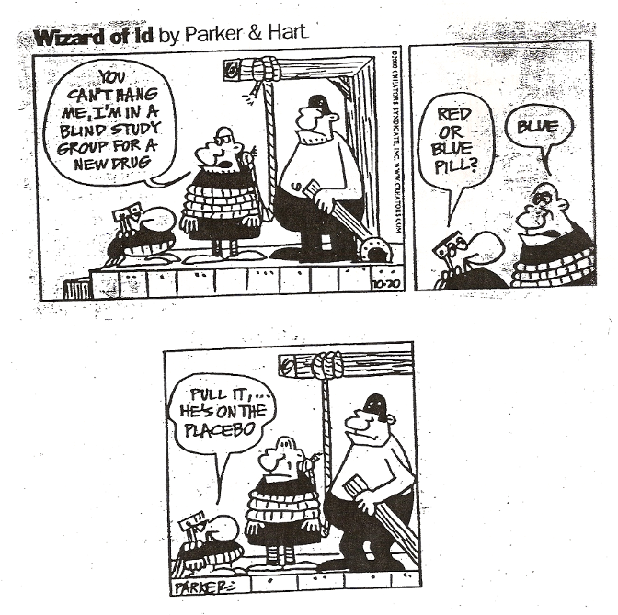

AP Stats Exam Questions by Topic
(courtesy of Derksen’s Sweet FAQ!)

Exploring data
1997 #1 2000 #3
2001 #1, 6a 2002 #1
2002 B #5, 6c2003 #1ab
2004 #12004B #5a
2005 #1a, 2d2005B #1
2006 #12006B #1
2007 #1ab2007B #1
2008 #12008B #1a
2009 #1ab2009B #1
2010 #6b2010B #1
2011B #1
Normal distribution
1999 #42002 #3a
1998 #6a2003 #3ab
2000 #6d2004B #3ab
2005B #6b2006B #3ac
2008B #5bc2009 #2a
2011 #1

Regression
1998 #2
1998 #4 2002 #4
1999 #12002 B #1
1999 #6c2003 B #1
2000 #12005 #3
2005B #5ab2006 #2ab
2007 #6abde2007B #4
2008 #3ab, 6b2008B #6abd
2010 #1b2010B#6abe
2011 #5abc2011B #6ab

Transformations for linearity
1997 #62004B #1
2007B #6cd
Designing surveys and experiments
1997 #22002#2
1998 #32002 B #3
1999 #3 2003 #4
2000 #5 2003 B #3a
2001 #42003 B #4abd
2004 #2, 3d, 5b2004B #2, 6c
2005 #1bc, 5ac2005B #3
2006 #52006B #5, 6f
2007 #2, 5a2007B #3
2008 #22008B #4a
2009 #32009B #4, 6a
2010 #1a, 4c2010B #2
2011 #32011B #2
Probability
1997 #3 2002 B #2
1999 #5 2003 B #2
2003 B #5a2004 #3bc, 4a
2005B #6c2006 #3b
2009B #22010B #5abc
2011 #2, 6b2011B #3ab
Random variables
1999 #52002 #3
2000#6bc2002 B #2
2001 #22004B #6b
2003 B #5b2004 #4bc
2005 #2abc2005B #2
2006 #3a2007B #2a
2008 #32008B #5a

Binomial/geometric & simulations
1998 #6bcde2004 #3a
2001 #32005B #6d
2003 #3c2006B #6c
2007B #2b2009 #2b
2010 #4ab2010B #3
2011B #c
CLT
1998 #12004B #3cd
2006 #3c2006B #3b
2007 #32007B #2c
2008B #32009 #2c
2010 #22011B #6cd
Inference with t for µ
1997 #52002 B #6a
1999 #6ab 2003 #1c
2000 #42003 B #4
2000 #22004 #6
2001 #52002 #5
2004B #4, 5bc2005 #6
2006 #42006B #4
2007 #1c, 42007B #5
2008 #6a2008B #1b-3-4b-6c
2009 #4, 6a2009B #5
2010 #52010B #4
2011 #4

Inference with z for p
1997 #4 2002 B #4
1998 #5 2003 #2, 6
2000 #6 2002 #6abd
2003B #3b, 62004B #6a
2005 #4, 5b2005B #4, 6a
2006B #2, 6abde2007 #5bcd
2007B #6a2008 #3c
2009 #52009B #3, 6b
2010 #32011 #6a
2011B #5

Chi-Square
1999 #2 2003 #5
2002 #6 2003 B #5c
2002 B #6b2004 #5a
2008 #52009 #1c
2010B #5d2011B #4

Inference for Regression
2001 #6c2005B #5c
2006 #2c2007 #6c
2007B #6b2008 #6c
2011 #5d

Stretching into something new!
2006 #62008 #6d
2009 #6bcd2009B #6cde
2010 #6cde2010B #6cd
2011 #6cd2011B #6ef

Random variables
1999 #52002 #3
2000#6bc2002 B #2
2001 #22004B #6b
2003 B #5b2004 #4bc
2005 #2abc2005B #2
2006 #3a2007B #2a
2008 #32008B #5a

Binomial/geometric & simulations
1998 #6bcde2004 #3a
2001 #32005B #6d
2003 #3c2006B #6c
2007B #2b2009 #2b
2010 #4ab2010B #3
2011B #c
CLT
1998 #12004B #3cd
2006 #3c2006B #3b
2007 #32007B #2c
2008B #32009 #2c
2010 #22011B #6cd
Inference with t for µ
1997 #52002 B #6a
1999 #6ab 2003 #1c
2000 #42003 B #4
2000 #22004 #6
2001 #52002 #5
2004B #4, 5bc2005 #6
2006 #42006B #4
2007 #1c, 42007B #5
2008 #6a2008B #1b-34b-6c
2009 #4, 6a2009B #5
2010 #52010B #4
2011 #4

Inference with z for p
1997 #4 2002 B #4
1998 #5 2003 #2, 6
2000 #6 2002 #6abd
2003B #3b, 62004B #6a
2005 #4, 5b2005B #4, 6a
2006B #2, 6abde2007 #5bcd
2007B #6a2008 #3c
2009 #52009B #3, 6b
2010 #32011 #6a
2011B #5

Chi-Square
1999 #2 2003 #5
2002 #6 2003 B #5c
2002 B #6b2004 #5a
2008 #52009 #1c
2010B #5d2011B #4

Inference for Regression
2001 #6c2005B #5c
2006 #2c2007 #6c
2007B #6b2008 #6c
2011 #5d

Stretching into something new!
2006 #62008 #6d
2009 #6bcd2009B #6cde
2010 #6cde2010B #6cd
2011 #6cd2011B #6ef
AP Stats Exam Questions by Topic
(courtesy of Derksen’s Sweet FAQ!)

Exploring data
1997 #1 2000 #3
2001 #1, 6a 2002 #1
2002 B #5, 6c 2003 #1ab
2004 #1 2004B #5a
2005 #1a, 2d 2005B #1
2006 #1 2006B #1
2007 #1ab 2007B #1
2008 #1 2008B #1a
2009 #1ab 2009B #1
2010 #6b 2010B #1
2011B #1
Normal distribution
1999 #4 2002 #3a
1998 #6a 2003 #3ab
2000 #6d 2004B #3ab
2005B #6b 2006B #3ac
2008B #5bc 2009 #2a
2011 #1
Regression
1998 #2
1998 #4 2002 #4
1999 #1 2002 B #1
1999 #6c 2003 B #1
2000 #1 2005 #3
2005B #5ab 2006 #2ab
2007 #6abde 2007B #4
2008 #3ab, 6b 2008B #6abd
2010 #1b 2010B#6abe
2011 #5abc 2011B #6ab
Transformations for linearity
1997 #6 2004B #1
2007B #6cd
Designing surveys and experiments
1997 #2 2002#2
1998 #3 2002 B #3
1999 #3 2003 #4
2000 #5 2003 B #3a
2001 #4 2003 B #4abd
2004 #2, 3d, 5b 2004B #2, 6c
2005 #1bc, 5ac 2005B #3
2006 #5 2006B #5, 6f
2007 #2, 5a 2007B #3
2008 #2 2008B #4a
2009 #3 2009B #4, 6a
2010 #1a, 4c 2010B #2
2011 #3 2011B #2
Probability
1997 #3 2002 B #2
1999 #5 2003 B #2
2003 B #5a 2004 #3bc, 4a
2005B #6c 2006 #3b
2009B #2 2010B #5abc
2011 #2, 6b 2011B #3ab

Greetings, 2011-2012 EVHS A.P. Statistician!

We’re Ken Mulsoff and Judy Hoffman, EVHS teachers who will be leading the AP Statistics course in 2011-2012. We suspect that the academic challenges of next fall may not be at the forefront of your thoughts right now, but perhaps things will change over the summer! We write to offer you a few ways to be a step ahead with a pre-warmed brain when AP Statistics gets rolling in September.

First, poke around under “AP Statistics” at the Eastview Stats site: http://www.district196.org/evhs/People/mulsoffweb/
You’ll find tips, hints, etc., and learn about the basics of AP Stats at Eastview.

Second, keep your eyes & ears open for the stats you’re exposed to every day…..

The weather broadcaster will tell you today’s average high temperature, and will often compare today's high with the average, but how do they really compare? Are you told how unusual today is compared to the average? How would you decide if a day is unusually hot or cool? How many degrees above the average make a day really unusual? What information could be given to help you make this decision?

Medical studies are often in the news. Do certain foods/drinks really extend (or shorten!) human life? How much does smoking really harm you? Are the people who volunteer for medical studies just like the rest of folks? Should I spend money on vitamins?

Elections are coming! Every good poll reports a margin of error, with a specified confidence level. What the heck is that truly measuring, what does it mean, and how is it calculated?

Third, there are many good books that deal with deep statistical ideas without getting too technical. Consider picking up one of these and giving it a read before school starts. (stars indicate favorites and/or an especially high recommendation)

** Outliers, by Malcolm Gladwell. Little, Brown, & Co 2008
** Innumeracy, by John Allen Paulos. Hill and Wang
** Freakonomics: A Rogue Economist Explores the Hidden Side of Everything, by Levitt & Dubner, 2005.
** A Mathematician Reads the Newspaper, by J. A. Paulos. Basic Books, 1995.
** Moneyball: The Art of Winning an Unfair Game, by M. Lewis. Norton, 2003
(tells how the Oakland A’s revamped their baseball team using basic stats)
* The Lady Tasting Tea, by D. Salsburg. Owl Books, 2001
* 200% of Nothing, by A. K. Dewdney. John Wiley and Sons, 1993.
Bringing Down the House: How Six Students Took Vegas for Millions, by Ben Mezrich
(Breaking Vegas & "21" movie are based on this book). Free Press
Fooled by Randomness: The Hidden Role of Chance in Life and in the Markets, by N. Taleb. Thomson, 2004
The Black Swan: The Impact of the Highly Improbable, by N. Taleb. Thomson, 2007
Tainted Truth: The Manipulation of Fact In America, by C. Crossen
The Ghost Map: The Story of London's Most Terrifying Epidemic—and How
It Changed Science, Cities, and the Modern World, by S. Johnson
The Tipping Point: How Little Things Can Make a Big Difference, by M. Gladwell, Little, Brown & Co., 2002

Fourth, as you complete THIS academic year, make sure you ‘finish strong’ and are fully prepared for the AP Statistics
opportunity. As described in the materials available when you registered, you must be a self-motivated student with a very strong Algebra II background -- generally ‘A’ grades, possibly ‘B’ – and, even more important, very strong scholarship and attendance habits. If you fit this description, super! If not, you might want to reconsider your course selection. Contact one of us (or your guidance counselor) with any questions.

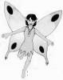
So…those were a few ideas to keep (or get!) your stat-brain rolling. Watch out -- if you're not careful, you might notice stats around you all the time. We can't wait to see you all in fall. In the meantime, we hope your summer is statistically significantly great. (p-value < 0.05)
Hi! I’m the Stats Fairy.

If you have any questions about anything, feel free to send a note.

Ken Mulsoff & Judy Hoffman ( kenneth.mulsoff@district196.org & judy.hoffman@district196.org ) EVHS Math/Stats/Computer Science Department

